Currently, the student exception is handling at a specific REST Controller, and CAN’T be used by other controller.

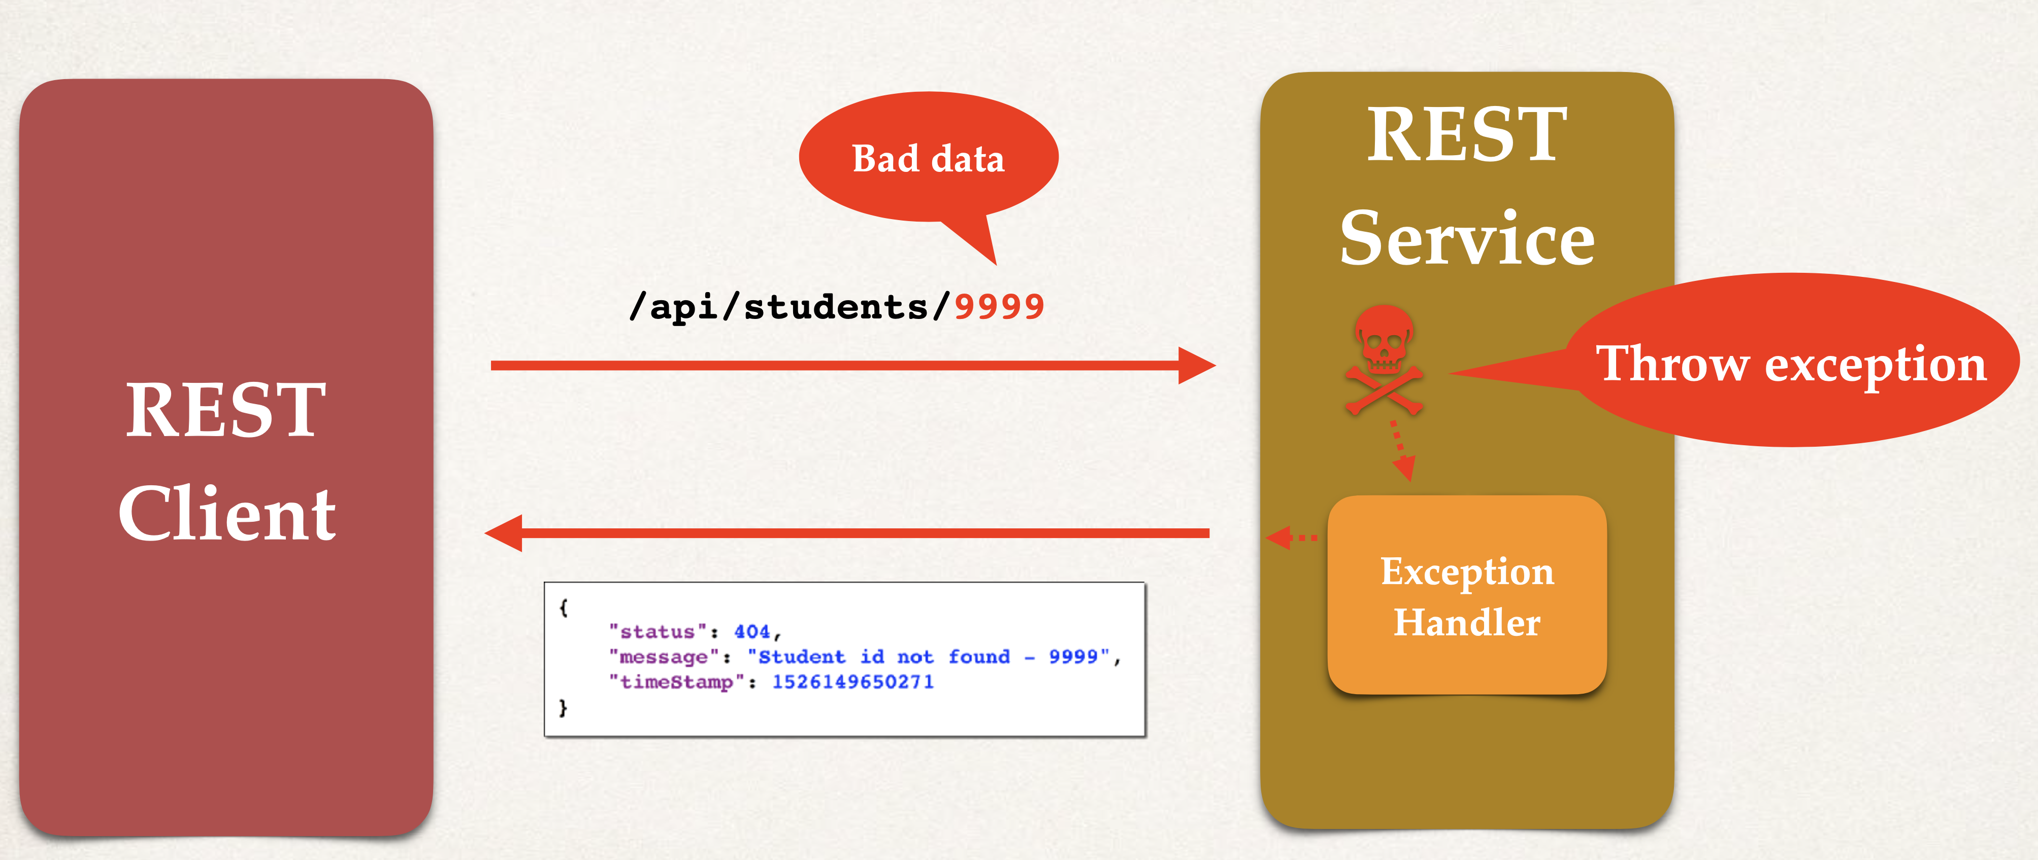

Now, we want to handle it globally

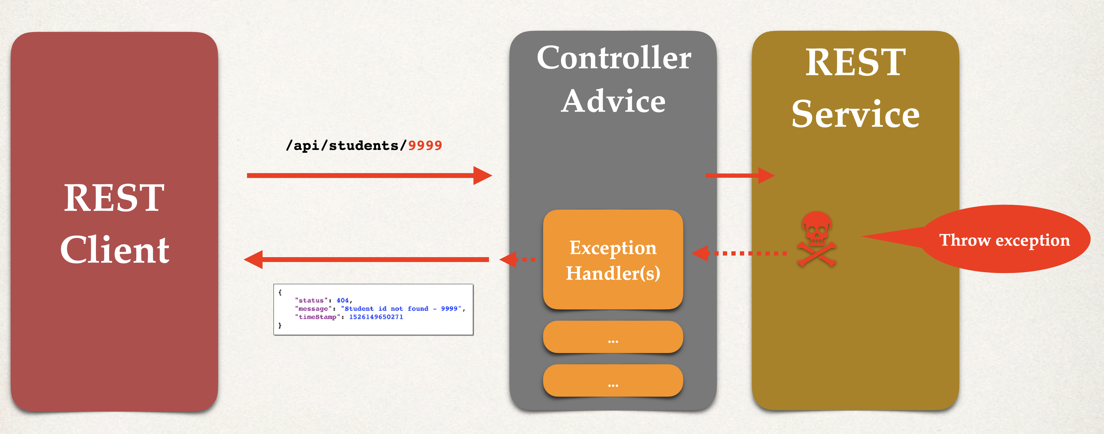

**Step 1**: Create new @ControllerAdvice

**Step 2**: Refactor REST service … remove exception handling code

**Step 3**: Add exception handling code to @ControllerAdvice